**Finding Tolerance for Deer: A Statistical Approach to Defining Tolerance**

**Melissa E. Stanger**

The Ohio State University

School of Environment and Natural Resources

Terrestrial Wildlife Ecology Laboratory

Environmental and Social Sustainability Laboratory

***Abstract-*** Tolerance of wildlife is important for state management agencies to understand, because when an individuals’ level of tolerance for a species is exceeded, passive inaction ceases, tolerance becomes intolerance, and action with the intention of negatively effecting the population is taken (Bruskotter et al., 2015). I first used Exploratory Factor Analysis (EFA) to determine the latent variable tolerance for wildlife. Then I used Confirmatory Factor Analysis (CFA) to confirm this analysis, as suggested by Costello and Osborne (2005). Then last of all I created a Generalized Linear Model explaining 27% of the variance in tolerance for wildlife.

***Key Terms-*** *Confirmatory Factor Analysis, Exploratory Factor Analysis, Generalized Linear Model, Tolerance*

*Introduction*

Sharing land with an abundance of wildlife has both positive and negative repercussions especially for agricultural producers (Conover, 1997). One might enjoy the chirp of a bird, hunting a deer, or even just seeing wildlife. However, many farmers and ranchers lose income due commercial crop damage caused by wildlife (Conover, 1994; Wywialowski, 1994). In a survey of United States agricultural producers from 1993 and 1994, 80% of respondents claimed to have damage caused by wildlife on their farm or ranch in the previous year. This same survey found that 54% of respondents reported incurring >$500 worth of wildlife damages per year (Conover, 1998). Out of all the species of nuisance wildlife in the United States, deer are the most common damage culprits for agricultural producers (Conover, 1998; Conover et al., 2018). However commercial crop damage or even garden damage are not the biggest concern when it comes to deer damage. In a survey of people living in Tompkins County, New York, 56% of respondents said their greatest concern about deer was deer-vehicle collisions (Stout et al., 1993). Deer vehicle collisions are a regular concern for many people. A study surveying exurban areas found that deer-vehicle collisions were a common concern for most respondents (84%) (Storm et al., 2007). Annually in the United States, there are approximately one to two million vehicle collisions with large animals (Huijser et al., 2007). This leaves a profound impression on the opinions towards deer for the people involved. Stout et al. (1993) found that personal involvement in a deer-vehicle collision and perceived risk of deer vehicle collisions greatly impact one’s preferences for the deer population level. Currently there is very little known about the state of deer damage or other wildlife damages in the state of Ohio. It is important to understand the extent of deer damage because interactions with wildlife effect what wildlife population levels humans are willing to tolerate (Lischka, 2008). Part of my goal with this paper is to show statistically how deer damage perceptions can explain part of the variance in tolerance of deer in Ohio.

When someone is highly tolerant of a wildlife species that means they exhibit passive restraint towards behaviors that would negatively impact the species regardless of wildlife damage (Bruskotter et al., 2015). However, not all humans are tolerant of wildlife and there is a point where passive inaction ceases, tolerance becomes intolerance, and action with the intention of negatively effecting the population is taken (Bruskotter et al., 2015). For example, farmers will tolerate deer damage to crops to an extent however there is a monetary threshold in which damage becomes intolerable. However, this threshold differs among areas (Pomerantz et al., 1986; Siemer and Decker, 1996; Craven et al., 1992).

Wildlife acceptance capacity is often used to measure tolerance (Bruskotter et al., 2015). Wildlife acceptance capacity is the highest wildlife population level that is acceptable to humans (Decker et al., 1988). When a wildlife population level is under an individual’s wildlife acceptance capacity it can be assumed that the “normal” human state of affected individuals is inaction or passive restraint, much like an individual that exhibits high tolerance of wildlife. Also like tolerance, wildlife acceptance capacity has a limit to what is acceptable, and when the population level exceeds an individuals wildlife acceptance capacity for that species, passive inaction ceases and action with the intention of negatively effecting the population may be taken by the individual or rather the individual obtains motivation to take such actions (Bruskotter et al., 2015). Bruskotter and Fulton (2012) went as far as to claim that wildlife acceptance capacity and tolerance for wildlife share the same construct.

My other goal with this paper is to statistically define the latent variable tolerance. As useful of a measure for tolerance wildlife acceptance capacity may seem, it is still only one simple measure and lacks the variability necessary for statistical tests or models that require a continuous variable. If other measures for tolerance of wildlife could be used alongside wildlife acceptance capacity to create the latent variable tolerance, then this would increase the variability in tolerance and thus qualify tolerance for deeper statistical analysis then before. In this paper I used factor analysis to determine what other variables, if any, also measure tolerance.

*Study Area and Population*

We sought to get a spatially explicit picture of perceptions of deer in Ohio by sampling Ohio landowners among each of Ohio’s 26 deer management units (DMU). Figure 1 displays Ohio divided-up into its 26 DMUs. We went to Dynata sampling firm, to purchase a sample of 13,750 landowners with >5 acres of land stratified by DMU (Slagle and Bruskotter, 2020).

Figure 1. Ohio’s Deer Management Units

*Data Collection*

We mailed survey packets (cover letter, survey, and return envelope) to the sample of 13,750 landowners in May of 2019. Each survey packet in the first mailing included a $1 cash incentive to improve response rates. landowners were sent a reminder postcard in June of 2019. Then in July of 2019 landowners who had not responded yet were sent a final survey packet (cover letter, survey, and return envelope). Respondents were given the opportunity in each mailing to take an identical survey online via the survey platform Qualtrics, in order to improve response times and reduce costs associated data entry. 5,342 of the 13,750 landowners responded, giving and adjusted response rate of 40% (Slagle and Bruskotter, 2020).

*Statistical Methods*

Before starting any statistical analysis, I removed all cases that responded NA to any of the questions I planned to use in analysis. After this was done, I was left with 3,674 landowners. This sample size of over 3000 is more than enough to perform Factor Analysis according to Costello and Osborne (2005).

Since not all the questions were answered on the same scale, I standardized all the variables before being put through the EFA and the CFA. I first used Exploratory Factor Analysis (EFA) to determine the latent variable tolerance. In the EFA I included the variables that measure acceptance capacity of deer, affect (this includes the items: I enjoy seeing and having deer around; I worry about the problems that deer cause; I generally regard deer as a nuisance; and I take comfort when I see deer, because it means things are as they should be), perceptions of deer damage (this includes the variables: garden damage, commercial crop damage, and deer vehicle collision), services offered by deer (this includes the variables: did you hunt deer in the last hunting season and did you lease your land for others to hunt), and whether or not the landowner is an agricultural operator. The reason for including whether or not the landowner is an agricultural operator is because this has a profound impact on whether landowners can experience commercial crop damage. I used the guidelines established by Costello and Osborne (2005) to determine that 2 factors should be retained. I started out by using an oblique rotation to see if the factors were correlated and found that the factors only had a correlation of .11. Tabachnick and Fidell (2007) suggest that if none of the factors correlate at .32 or above then an orthogonal rotation should be used, so I used the orthogonal rotation varimax. Then I used Confirmatory Factor Analysis (CFA) to confirm this analysis, as suggested by Costello and Osborne (2005), also using the orthogonal rotation varimax. The CFA included the variables acceptance capacity for deer and four affect measures. The four affect measures are: I enjoy seeing and having deer around; I worry about the problems that deer cause; I generally regard deer as a nuisance; and I take comfort when I see deer, because it means things are as they should be.

I was careful to test all the statistical assumptions of Factor Analysis which according to Yong and Pearce (2013) are univariate and multivariate normality within the data, and no univariate or multivariate outliers. Using the Henze-Zirkler's test and the Doornik-Hansen's test I determined that the assumption of multivariate normality was not met. Using a pairs.panels matrix in R (Figure 2), I visually determined that the assumption of univariate normality was not met by looking at the histograms of the individual variables. These can be seen in Figure 2, displayed diagonally from the top left corner of the matrix to the bottom right corner of the matrix. Lastly, I used Mahalanobis Distances to look for extreme outliers and determined that there were no outliers of concern.

Figure 2. Diagnostics of Variables Involved in Factor Analysis

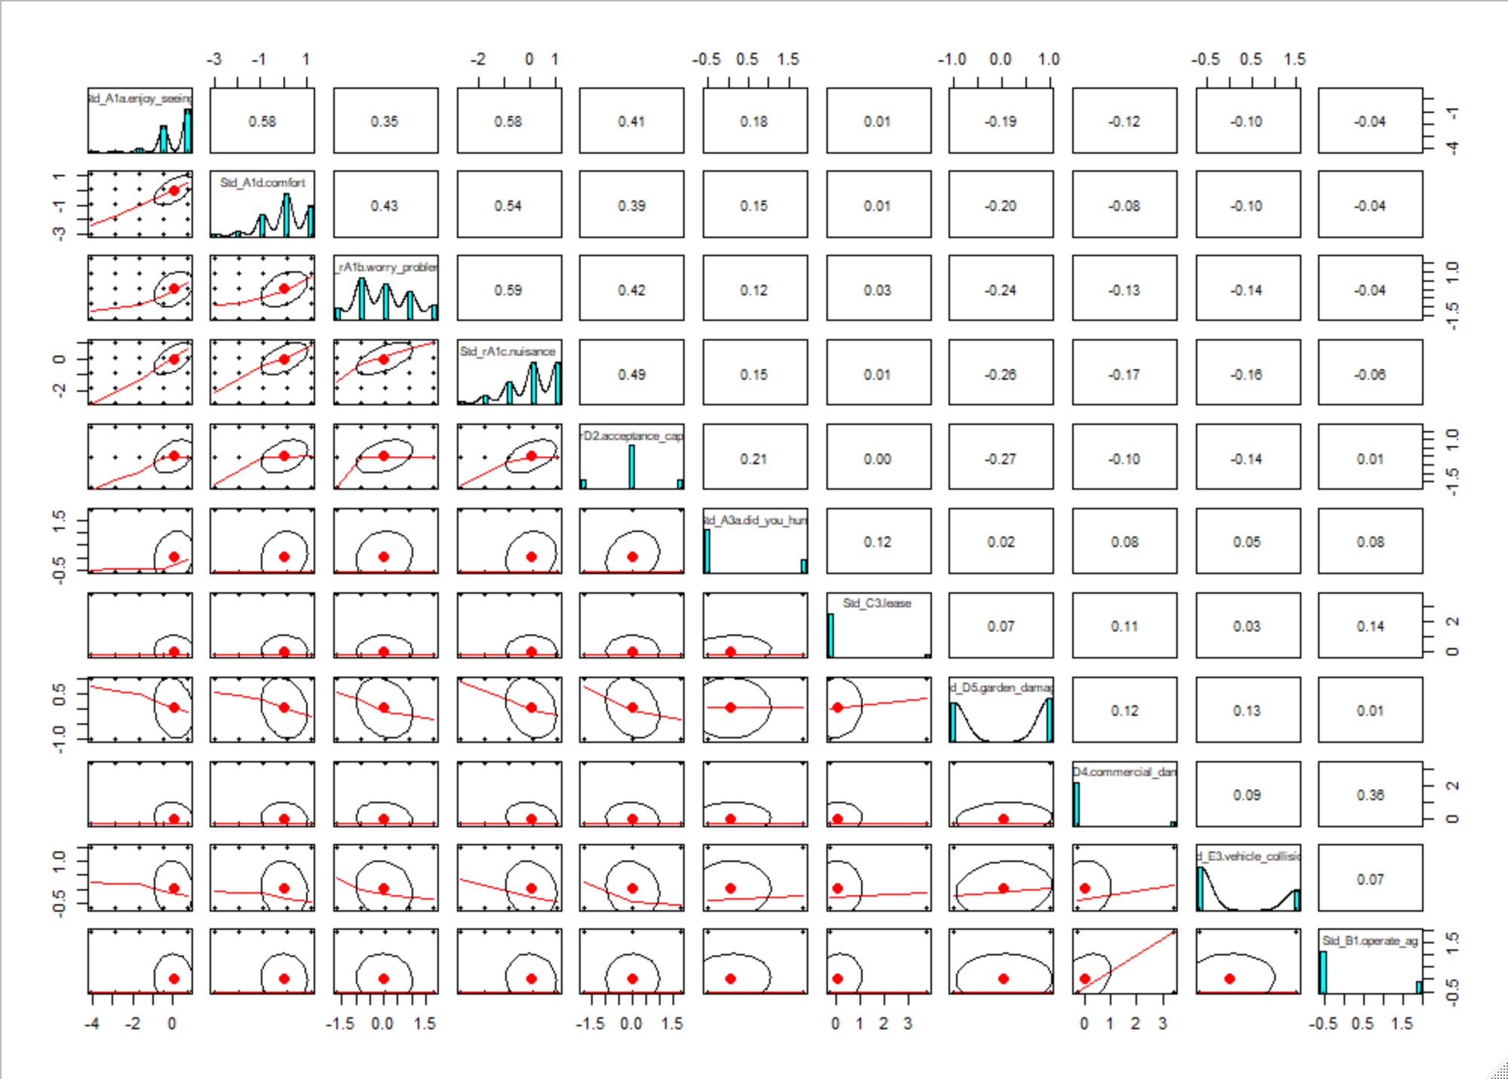

Then last of all I created a Generalized Linear Model (GLM) explaining tolerance. To prepare the data for regression analysis I first created two new variables, tolerance and conservation stewardship. The latent variable tolerance, which was discovered through EFA and confirmed through CFA, is an average of the standardized variables acceptance capacity for deer, two positive affect measures (I enjoy seeing and having deer around; and I take comfort when I see deer, because it means things are as they should be), and two negative affect measures (I worry about the problems that deer cause; and I generally regard deer as a nuisance). The conservation stewardship variable was created using the mean of a question block containing five different conservation actions that respondents might do in the next 6 months measured on a five-point Likert scale. To find the correct distribution to use for the GLM and test which variables should be included, I created a candidate model set with 19 slightly different models. Then I used an Akaike information criterion table to determine which model had the best fit. The model that I considered to have the best fit used gaussian distribution with the identity link. In the generalized Linear model, my dependent variable is tolerance and my independent variables are: did you experience garden damage due to wildlife in the past 2 years, did you experience commercial crop damage due to wildlife in the past 2 years, have you or someone in your immediate family experience a deer-vehicle collision in Ohio in the past 2 years, do you self-identify as a farmer or rancher, do you self-identify as a hunter, do you self-identify as an environmentalist, do you self-identify as an animal rights advocate, do you self-identify as a property rights advocate, conservation stewardship, and deer management unit of residence.

I was also careful to meet all the assumptions of GLMs which according to Peña and Slate (2006) are linearity, normality, homoscedasticity, and no multicollinearity. I looked at the plot of the residuals vs fitted values and found a straight line which I used to determine that the assumption of linearity was met. I created a histogram of the dependent variable tolerance to check if it was normally distributed. Then looked at the normal Q-Q plot to look at the distribution of the residuals which fallowed the line well, so I determined that the assumption of normality was met. I looked at the scale-location diagnostic plot and found an even spread of points, so I determined that the assumption of homoscedasticity was met. To test for multicollinearity, I looked at the correlation matrix and found one pair of variables of concern that correlated at .75 (I hunted deer in the last hunting season and I self-identify as a hunter), so I then checked the variance inflation factors for the variables in question. The variance inflation factors for these two variables were 2.39 and 2.59, so according to variance inflation factor cutoff criteria set forth by Craney and Surles (2002), I removed the variable “I hunted deer in the last hunting season” from my model. I also looked at the cook’s distance and determined that there were no outliers of concern.

*Results*

Keep in mind while looking at these results, that the assumptions of multivariate and univariate normality were not met. The loadings from the EFA in table 1 suggested that there is a latent variable for tolerance that exists containing the acceptance capacity for deer and four affect measures. The four affect measures are: I enjoy seeing and having deer around; I worry about the problems that deer cause; I generally regard deer as a nuisance; and I take comfort when I see deer, because it means things are as they should be. On the first axis of my EFA, which I defined as tolerance, the variable garden damage has a .32 loading. I choose to not include the variable garden damage in the interpretation of tolerance because the variable garden damage was on the edge of significance (Tabachnick and Fidell, 2007), and relatively low-loading compared to the other significant variable loadings which were all above .6 creating a gap in loadings across the first factor. Furthermore, it makes sense from a sociological perspective to not include garden damage in the interpretation of tolerance because garden damage is a measure of damage perception, whereas the other variables with significant loadings are all measures of different forms of attitude. Both reasonings for not including garden damage in the interpretation of tolerance are acceptable according to Tabachnick and Fidell (2007).

|  |  |  |
| --- | --- | --- |
| Table 1. Exploratory Factor Analysis Loadings | | |
|  | Factor 1 | Factor 2 |
| Enjoy Seeing | 0.70 |  |
| Comfort | 0.68 |  |
| Worry About Problems | 0.65 |  |
| Nuisance | 0.83 |  |
| Acceptance Capacity | 0.61 |  |
| Commercial Damage |  | 0.60 |
| Garden Damage | -0.32 |  |
| Vehicle Collision |  |  |
| Agricultural Operator |  | 0.56 |
| Did You Hunt? | 0.22 | 0.22 |
| Lease |  | 0.23 |

Next, I performed a Confirmatory Factor Analysis (CFA) to confirm the discovery of the latent variable tolerance using acceptance capacity for deer and the four measures of affect (Table 2). The larger the loading is, the more the variable is a measure of the factor (Tabachnick and Fidell, 2007). According to Comrey and Lee (1992), the factor loading for the variable “I generally regard deer as a nuisance” is excellent; the factor loadings for variables “I enjoy seeing and having deer around”, “I worry about the problems that deer cause”, and “I take comfort when I see deer, because it means things are as they should be” are very good; and the factor loading for the variable acceptance capacity for deer is good.

|  |  |
| --- | --- |
| Table 2. Confirmatory Factor Analysis Loadings | |
|  | Factor 1 |
| Enjoy Seeing | 0.70 |
| Comfort | 0.69 |
| Worry About Problems | 0.65 |
| Nuisance | 0.84 |
| Acceptance Capacity | 0.59 |
|  |  |
| SS Loadings | 2.44 |
| Proportion Variance | 0.49 |

Lastly, I used A Generalized linear model to explain tolerance. The model that I considered to have the best fit used gaussian distribution with the identity link. My independent variables were: did you experience garden damage due to wildlife in the past 2 years, did you experience commercial crop damage due to wildlife in the past 2 years, have you or someone in your immediate family experience a deer-vehicle collision in Ohio in the past 2 years, do you self-identify as a farmer or rancher, do you self-identify as a hunter, do you self-identify as an environmentalist, do you self-identify as an animal rights advocate, do you self-identify as a property rights advocate, conservation stewardship, and deer management unit of residence. The dispersion parameter was .42 meaning that there is some under dispersion. All the p-values, with the exception of the fixed effects of deer management unit of residence, were equal to or less than .01, and the r^2 value was .27 meaning that 27% of the variance in tolerance can be explained by these independent variables.

*Discussion*

A clear, latent variable for tolerance does exist. This was proven in both the EFA and the CFA. The latent variable tolerance includes an average of the standardized variables: acceptance capacity for deer; “I enjoy seeing and having deer around”; “I worry about the problems that deer cause”; “I generally regard deer as a nuisance”; and “I take comfort when I see deer, because it means things are as they should be”. The last four variables listed are affect measures. All five of these variables are measures of attitude towards deer. This agrees with Treves (2012) who claimed that attitude measures are useful for indicating tolerance.

Perceptions of deer damage (measured by variables: did you experience garden damage due to wildlife in the past 2 years, did you experience commercial crop damage due to wildlife in the past 2 years, have you or someone in your immediate family experience a deer-vehicle collision in Ohio in the past 2 years) turned out to be an important part of the GLM explaining tolerance. These three variables of perceptions of deer damage alone explain 12% of the variation in tolerance. This is supported by Lischka (2008) who found that a human’s perceptions of the effects of interactions with a wildlife population directly influence the acceptance capacity for deer of that species which is one of my measures for tolerance. However, perceptions of deer damage were not the only significant independent variables in the GLM. Other independent variables used to explain tolerance were social group self-identification (farmer/rancher, hunter, environmentalist, animal rights advocate, and property rights advocate), conservation stewardship, and deer management unit of residence. Together these variables with perceptions of deer damage explain 27% of the variance in tolerance.

*Literature Cited*

Bruskotter, J. T. & Fulton, D. C. Will Hunters Steward Wolves? A Comment on Treves and Martin. *Society & Natural Resources* **25**, 97–102 (2012).

Bruskotter, J. T., Singh, A., Fulton, D. C. & Slagle, K. Assessing Tolerance for Wildlife: Clarifying Relations Between Concepts and Measures. *Human Dimensions of Wildlife* **20**, 255–270 (2015).

Comrey, A. L., & Lee, H. B. A First Course in Factor Analysis (2nd ed.). *Hillsdale, NJ: Lawrence Erlbaum Associates* (1992)*.*

Conover, M. R. Perceptions of grass-roots leaders of the agricultural community about wildlife damage on their farms and ranches. Wildlife Society Bulletin **22**, 94-100 (1994).

Conover, M. R. Monetary and intangible valuation of deer in the United States. Wildlife Society Bulletin **25**, 298-305 (1997).

Conover, M. R. Perceptions of American Agricultural Producers about Wildlife on Their Farms and Ranches. *Wildlife Society Bulletin (1973-2006)* **26**, 597–604 (1998).

Conover, M. R., Butikofer, E. & Decker, D. J. Wildlife damage to crops: Perceptions of agricultural and wildlife leaders in 1957, 1987, and 2017. *Wildlife Society Bulletin* **42**, 551–558 (2018).

Costello, A. B. & Osborne, J. Best practices in exploratory factor analysis: four recommendations for getting the most from your analysis. *Exploratory Factor Analysis* **10**, 10 (2005).

Craney, T. A. & Surles, J. G. Model-Dependent Variance Inflation Factor Cutoff Values. *Quality Engineering* **14**, 391–403 (2002).

Craven, S. R., Decker, D. J., Siemer, W. E. & Hygnstrom, S. E. Survey use and landowner tolerance in wildlife damage management. *Transactions of the North American Wildlife and Natural Resources Conference* **57**:75-88 (1992).

Decker, D. J. & Purdy, K. G. Toward A Concept of Wildlife Acceptance Capacity in Wildlife Management. *Wildlife Society Bulletin (1973-2006)* **16**, 53–57 (1988).

Huijser, M. P., McGowen, P. T., Fuller, J., Hardy, A. & Kociolek, A. Wildlife-Vehicle Collision Reduction Study: Report to Congress. (2007).

Lischka, S. A., Riley, S. J. & Rudolph, B. A. Effects of Impact Perception on Acceptance Capacity for White-Tailed Deer. *The Journal of Wildlife Management* **72**, 502–509 (2008).

Peña, E. A. & Slate, E. H. Global Validation of Linear Model Assumptions. *Journal of the American Statistical Association* **101**, 341–354 (2006).

Pomerantz, G. A., NG, C. & Decker, D. J. Summary of research on human tolerance of wildlife damage. Natural Resources Research and Extension Series No. 25, *Department of Natural Resources, Cornell University Agricultural Experiment Station, New York State College of Agricultural and Life Sciences, Cornell University, Ithaca, USA* (1986).

Siemer, W. E. & Decker, D. J. Consideration of attitudes and values in deer management. Pages 67-85 in A. N. Rowan and J. C. Weer, editors. Living with wildlife: the biology and sociology of suburban deer and beaver. *Tufts Center for Animals and Public Policy, North Grafton, Massachusetts, USA* (1996).

Slagle, K.M, and Bruskotter, J.T. Deer in Ohio: Results from the 2019 Survey of Hunters and Landowners. *The Ohio State University, School of Environment and Natural Resources* (2020).

Storm, D. J., Nielsen, C. K., Schauber, E. M. & Woolf, A. Deer–human conflict and hunter access in an exurban landscape. *Human-Wildlife Conflicts* **1**, 53–59 (2007).

Stout, R. J., Stedman, R. C., Decker, D. J. & Knuth, B. A. Perceptions of Risk from Deer-Related Vehicle Accidents: Implications for Public Preferences for Deer Herd Size. *Wildlife Society Bulletin (1973-2006)* **21**, 237–249 (1993).

Tabachnick, B. G. & Fidell, L.S. Using Multivariate Statistics Fifth Edition. *Pearson Education Limited* (2007).

Treves, A. Tolerant Attitudes Reflect an Intent to Steward: A Reply to Bruskotter and Fulton. *Society & Natural Resources* **25**, 103–104 (2012).

Wywialowski, A. P. Agricultural producers' perceptions on wildlife-caused losses. *Wildlife Society Bulletin* **22**,370-382 (1994).